**MONOPOLY**

A **monopoly market** is a type of market structure characterized by the existence of a single seller or producer that dominates the entire market for a particular good or service. In this scenario, the monopolist faces no competition, giving it significant control over pricing and output.

**Key Features of a Monopoly Market:**

1. **Single Seller**: Only one firm supplies the product or service.
2. **Unique Product**: No close substitutes are available for the product.
3. **High Barriers to Entry**: New competitors find it difficult or impossible to enter the market.
4. **Price Maker**: The monopolist has the power to set prices, constrained only by demand.
5. **Lack of Competition**: No rivalry exists within the market.

**Causes for the Emergence of a Monopoly:**

1. **Natural Monopoly**: When a single firm can produce the entire output at a lower cost than multiple firms due to economies of scale (e.g., utilities like water or electricity).
2. **Legal Barriers**: Government grants exclusive rights through patents, copyrights, or licensing (e.g., pharmaceutical patents).
3. **Control Over Essential Resources**: If a firm controls a critical resource necessary for production, it can create a monopoly (e.g., diamond mines controlled by De Beers).
4. **Technological Superiority**: Firms with advanced technology or unique innovations can dominate the market (e.g., early dominance of Microsoft in operating systems).
5. **Mergers and Acquisitions**: Consolidation through mergers can eliminate competitors and create a monopoly.
6. **Network Effects**: Products or services that become more valuable as more people use them can lead to monopolistic dominance (e.g., social media platforms or software ecosystems).
7. **High Start-Up Costs**: Industries with significant initial investment requirements discourage new entrants (e.g., aerospace or telecommunications).
8. **Brand Loyalty**: A firm with strong brand recognition and customer loyalty can monopolize a market segment (e.g., Google in search engines).

Monopolies can sometimes be beneficial (e.g., in natural monopolies where regulation ensures efficient pricing), but they often lead to issues like higher prices, reduced innovation, and limited choices for consumers.

**Equilibrium in Monopoly**

The conditions for Equilibrium in Monopoly are the same as those under perfect competition. The marginal cost (MC) is equal to the marginal revenue (MR) and the MC curve cuts the MR [curve](https://www.toppr.com/guides/maths/application-of-integrals/area-under-simple-curves/) from below. In this article, we will understand Equilibrium in Monopoly in detail.

**A Firm’s Short-Run Equilibrium in Monopoly**

Like in perfect competition, there are three possibilities for a firm’s Equilibrium in Monopoly. These are:

1. The firm earns normal profits – If the average cost = the average revenue
2. It earns super-normal profits – If the average cost < the average revenue
3. It incurs losses – If the average cost > the [average](https://www.toppr.com/guides/principles-and-practice-of-accounting/average-due-date/meaning-calculation-of-average-due-date-in-various-situations/) revenue

**Normal Profits**

A firm earns normal profits when the average cost of [production](https://www.toppr.com/guides/business-economics/theory-of-production-and-cost/meaning-of-production/) is equal to the average revenue for the corresponding output.

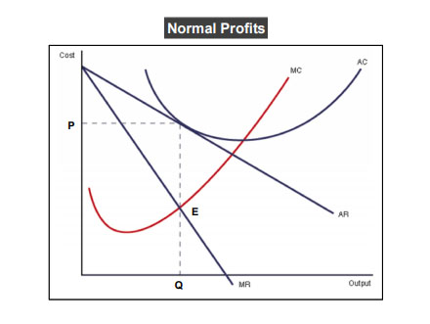

In the figure above, you can see that the MC curve cuts the MR curve at the equilibrium point E. Also, the AC curve touches the AR curve at a point corresponding to the same point. Therefore, the firm earns normal profits.

**Super-normal Profits**

A firm earns super-normal profits when the average cost of production is less than the average revenue for the corresponding output.

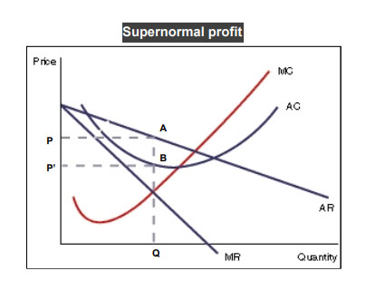

In the figure above, you can see that the price per unit = OP = QA. Also, the cost per unit = OP’. Therefore, the firm is earning more and incurring a lesser cost. In this case, the per unit profit is

OP – OP’ = PP’

Also, the total profit earned by the monopolist is PP’BA.

**Losses**

A firm earns losses when the average cost of production is higher than the average revenue for the corresponding [output](https://www.toppr.com/guides/computer-aptitude-and-knowledge/basics-of-computers/input-and-output-devices/).

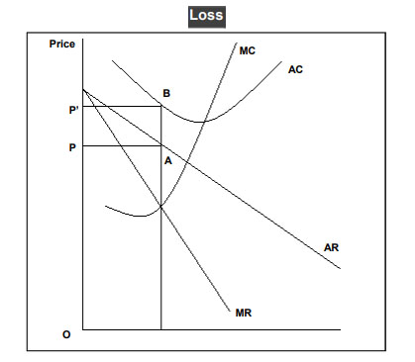

In the figure above, you can see that the average cost curve lies above the average revenue curve for the same [quantity](https://www.toppr.com/guides/maths/the-fish-tale/size-and-quantity/). The average revenue = OP and the average cost = OP’. Therefore, the firm is incurring an average loss of PP’ and the total loss is PP’BA. In the short-run, a monopolist sometimes sets a lower price and incurs losses to keep new firms away.

**A Firm’s Long-run Equilibrium in Monopoly**

In the long-run, a monopolist can vary all the inputs. Therefore, to determine the equilibrium of the firm, we need only two cost curves – the AC and the MC. Further, since the monopolist exits the [market](https://www.toppr.com/guides/business-economics/meaning-and-types-of-markets/market-meaning-and-classification/) if he is operating at a loss, the demand curve must be tangent to the AC curve or lie to the right and intersect it twice.

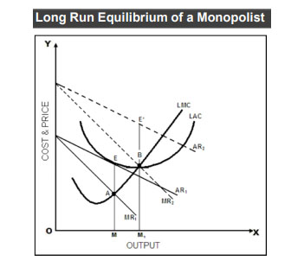

As you can see above, there are two alternative cases for the determination of Equilibrium in Monopoly:

* With normal profits
* With super-normal profits

We have not taken the loss scenario here because if the monopolist incurs losses in the long-run, he will stop operating.

**Case 1**

The demand curve AR1 is tangent to AC or LAC at point E. Remember, if the demand curve lies to the left of the AC curve, then the monopolist is unable to recover his costs and closes down.

However, if the AR curve is [tangent](https://www.toppr.com/guides/maths/application-of-derivatives/tangents-and-normals/) to the AC curve, then the monopolist can recover his costs and stay in the market.

Further, note that the perpendicular drawn from point E to the X-axis, the MC curve, and the MR curve are concurrent at point A.

Therefore, all the conditions of equilibrium are satisfied. The monopolist produces OM quantity and sells it at a price of EM per unit which covers its average costs + normal profits.

**Case 2**

The marginal revenue curve MR2 cuts the MC curve from below at point B. The corresponding height of the AR2 curve is E’M1.

Hence, the monopolist produces OM1 quantity and sells it at E’M1 per unit to earn an extra profit of E’B per unit. Being a [monopoly](https://www.toppr.com/guides/business-economics-cs/analysis-of-market/monopoly/), this extra profit is not lost to competition or newer firms entering the [industry](https://www.toppr.com/guides/general-awareness/industrial-development-and-foreign-trade/introduction-to-industry/).

Here is a detailed comparison between **Perfect Competition** and **Monopoly** based on key characteristics:

|  |  |  |
| --- | --- | --- |
| **Aspect** | **Perfect Competition** | **Monopoly** |
| **Number of Sellers** | Large number of sellers, none of which can influence the market price. | Single seller dominates the entire market. |
| **Market Power** | No market power; firms are price takers. | Significant market power; the monopolist is a price maker. |
| **Product Nature** | Homogeneous (identical) products. | Unique product with no close substitutes. |
| **Entry and Exit** | Free entry and exit for firms in the long run. | High barriers to entry prevent new firms from entering the market. |
| **Demand Curve** | Perfectly elastic (horizontal) demand curve. | Downward-sloping demand curve. |
| **Price** | Determined by the market; firms cannot influence it. | Determined by the monopolist, constrained by the demand curve. |
| **Profit in Long Run** | Normal profit due to free entry and exit of firms. | Can earn supernormal (economic) profit due to barriers to entry. |
| **Efficiency** | Allocatively and productively efficient in the long run. | Neither allocatively nor productively efficient. |
| **Consumer Choice** | Consumers have many choices due to competition. | Limited choice as only one firm supplies the product. |
| **Advertising** | Little to no need for advertising as products are homogeneous. | Advertising is often used to promote the product. |
| **Example** | Agricultural products (e.g., wheat, rice). | Utilities like electricity or water supply. |

**Key Differences Explained:**

1. **Market Power**:
   * In perfect competition, firms have no control over price. They accept the price set by market forces (demand and supply).
   * In a monopoly, the firm has complete control over the price due to the lack of competition.
2. **Entry Barriers**:
   * Perfect competition has no significant barriers to entry or exit, allowing new firms to join freely.
   * Monopolies are protected by barriers such as legal restrictions, high start-up costs, or control of resources.
3. **Profit Levels**:
   * Perfectly competitive firms earn normal profits in the long run due to competition driving prices to the point where economic profits are zero.
   * A monopolist can sustain supernormal profits in the long run because no new firms can enter to compete away these profits.
4. **Efficiency**:
   * Perfect competition leads to optimal allocation of resources and cost efficiency, benefiting society.
   * Monopoly often leads to inefficiencies, including higher prices and restricted output, which can harm consumer welfare.

This comparison highlights the stark differences between these two market structures in terms of competition, pricing, and efficiency.